NETWORK TRAFFIC MANAGEMENT:

SYSTEM ROUTES:

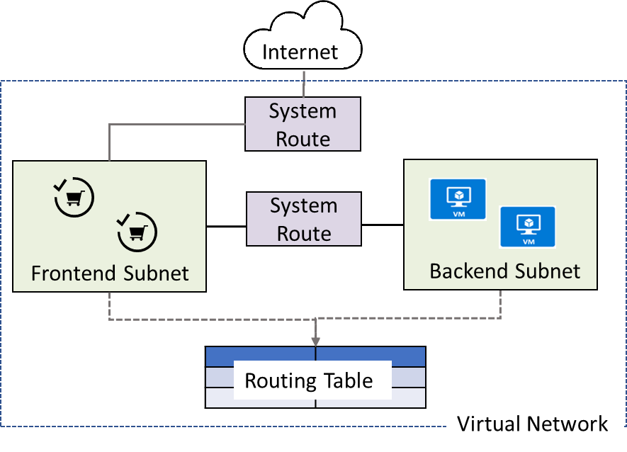

Azure automatically creates system routes and assigns the routes to each subnet in a virtual network. You can't create system routes, nor can you remove system routes, but you can override some system routes with custom routes. Azure creates default system routes for each subnet, and adds additional optional default routes to specific subnets, or every subnet, when you use specific Azure capabilities.

USED DEFINED ROUTES:

You create custom routes by either creating user-defined routes, or by exchanging border gateway protocol (BGP) routes between your on-premises network gateway and an Azure virtual network gateway.

User-defined
You can create custom, or user-defined(static), routes in Azure to override Azure's default system routes, or to add additional routes to a subnet's route table. In Azure, you create a route table, then associate the route table to zero or more virtual network subnets. Each subnet can have zero or one route table associated to it. To learn about the maximum number of routes you can add to a route table and the maximum number of user-defined route tables you can create per Azure subscription, see Azure limits. If you create a route table and associate it to a subnet, the routes within it are combined with, or override, the default routes Azure adds to a subnet by default.
You can specify the following next hop types when creating a user-defined route:
- Virtual appliance: A virtual appliance is a virtual machine that typically runs a network application, such as a firewall. To learn about a variety of pre-configured network virtual appliances you can deploy in a virtual network, see the Azure Marketplace. When you create a route with the virtual appliance hop type, you also specify a next hop IP address. The IP address can be:
  - The private IP address of a network interface attached to a virtual machine. Any network interface attached to a virtual machine that forwards network traffic to an address other than its own must have the Azure Enable IP forwarding option enabled for it. The setting disables Azure's check of the source and destination for a network interface. Learn more about how to enable IP forwarding for a network interface. Though Enable IP forwarding is an Azure setting, you may also need to enable IP forwarding within the virtual machine's operating system for the appliance to forward traffic between private IP addresses assigned to Azure network interfaces. If the appliance must route traffic to a public IP address, it must either proxy the traffic, or network address translate the private IP address of the source's private IP address to its own private IP address, which Azure then network address translates to a public IP address, before sending the traffic to the Internet. To determine required settings within the virtual machine, see the documentation for your operating system or network application. To understand outbound connections in Azure, see Understanding outbound connections.
Note
Deploy a virtual appliance into a different subnet than the resources that route through the virtual appliance are deployed in. Deploying the virtual appliance to the same subnet, then applying a route table to the subnet that routes traffic through the virtual appliance, can result in routing loops, where traffic never leaves the subnet.
  - The private IP address of an Azure internal load balancer. A load balancer is often used as part of a high availability strategy for network virtual appliances.
You can define a route with 0.0.0.0/0 as the address prefix and a next hop type of virtual appliance, enabling the appliance to inspect the traffic and determine whether to forward or drop the traffic. If you intend to create a user-defined route that contains the 0.0.0.0/0 address prefix, read 0.0.0.0/0 address prefix first.
- Virtual network gateway: Specify when you want traffic destined for specific address prefixes routed to a virtual network gateway. The virtual network gateway must be created with type VPN. You cannot specify a virtual network gateway created as type ExpressRoute in a user-defined route because with ExpressRoute, you must use BGP for custom routes. You can define a route that directs traffic destined for the 0.0.0.0/0 address prefix to a route-based virtual network gateway. On your premises, you might have a device that inspects the traffic and determines whether to forward or drop the traffic. If you intend to create a user-defined route for the 0.0.0.0/0 address prefix, read 0.0.0.0/0 address prefix first. Instead of configuring a user-defined route for the 0.0.0.0/0 address prefix, you can advertise a route with the 0.0.0.0/0 prefix via BGP, if you've enabled BGP for a VPN virtual network gateway.
- None: Specify when you want to drop traffic to an address prefix, rather than forwarding the traffic to a destination. If you haven't fully configured a capability, Azure may list None for some of the optional system routes. For example, if you see None listed as the Next hop IP address with a Next hop type of Virtual network gateway or Virtual appliance, it may be because the device isn't running, or isn't fully configured. Azure creates system default routes for reserved address prefixes with None as the next hop type.
- Virtual network: Specify when you want to override the default routing within a virtual network. See Routing example, for an example of why you might create a route with the Virtual network hop type.
- Internet: Specify when you want to explicitly route traffic destined to an address prefix to the Internet, or if you want traffic destined for Azure services with public IP addresses kept within the Azure backbone network.
You cannot specify VNet peering or VirtualNetworkServiceEndpoint as the next hop type in user-defined routes. Routes with the VNet peering or VirtualNetworkServiceEndpoint next hop types are only created by Azure, when you configure a virtual network peering, or a service endpoint.
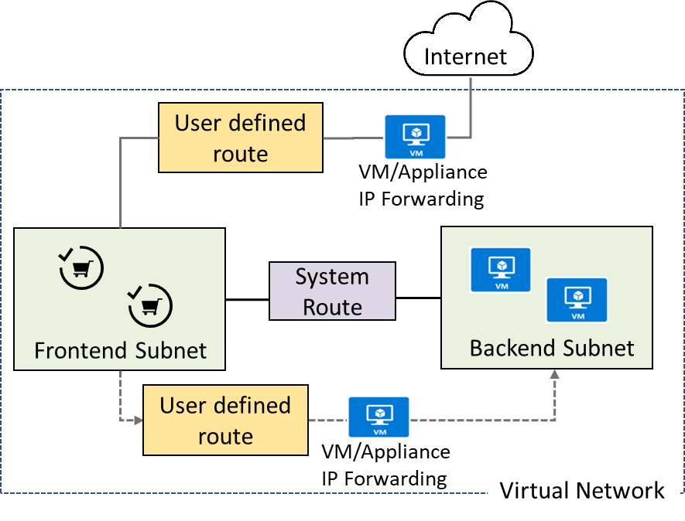

SERVICE ENDPOINTS:
Virtual Network (VNet) service endpoint provides secure and direct connectivity to Azure services over an optimized route over the Azure backbone network. Endpoints allow you to secure your critical Azure service resources to only your virtual networks. Service Endpoints enables private IP addresses in the VNet to reach the endpoint of an Azure service without needing a public IP address on the VNet.
This feature is available for the following Azure services and regions. The Microsoft.* resource is in parenthesis. Enable this resource from the subnet side while configuring service endpoints for your service:
Generally available
- Azure Storage (Microsoft.Storage): Generally available in all Azure regions.
- Azure SQL Database (Microsoft.Sql): Generally available in all Azure regions.
- Azure Synapse Analytics (Microsoft.Sql): Generally available in all Azure regions for dedicated SQL pools (formerly SQL DW).
- Azure Database for PostgreSQL server (Microsoft.Sql): Generally available in Azure regions where database service is available.
- Azure Database for MySQL server (Microsoft.Sql): Generally available in Azure regions where database service is available.
- Azure Database for MariaDB (Microsoft.Sql): Generally available in Azure regions where database service is available.
- Azure Cosmos DB (Microsoft.AzureCosmosDB): Generally available in all Azure regions.
- Azure Key Vault (Microsoft.KeyVault): Generally available in all Azure regions.
- Azure Service Bus (Microsoft.ServiceBus): Generally available in all Azure regions.
- Azure Event Hubs (Microsoft.EventHub): Generally available in all Azure regions.
- Azure Data Lake Store Gen 1 (Microsoft.AzureActiveDirectory): Generally available in all Azure regions where ADLS Gen1 is available.
- Azure App Service (Microsoft.Web): Generally available in all Azure regions where App service is available.
- Azure Cognitive Services (Microsoft.CognitiveServices): Generally available in all Azure regions where Cognitive services are available.
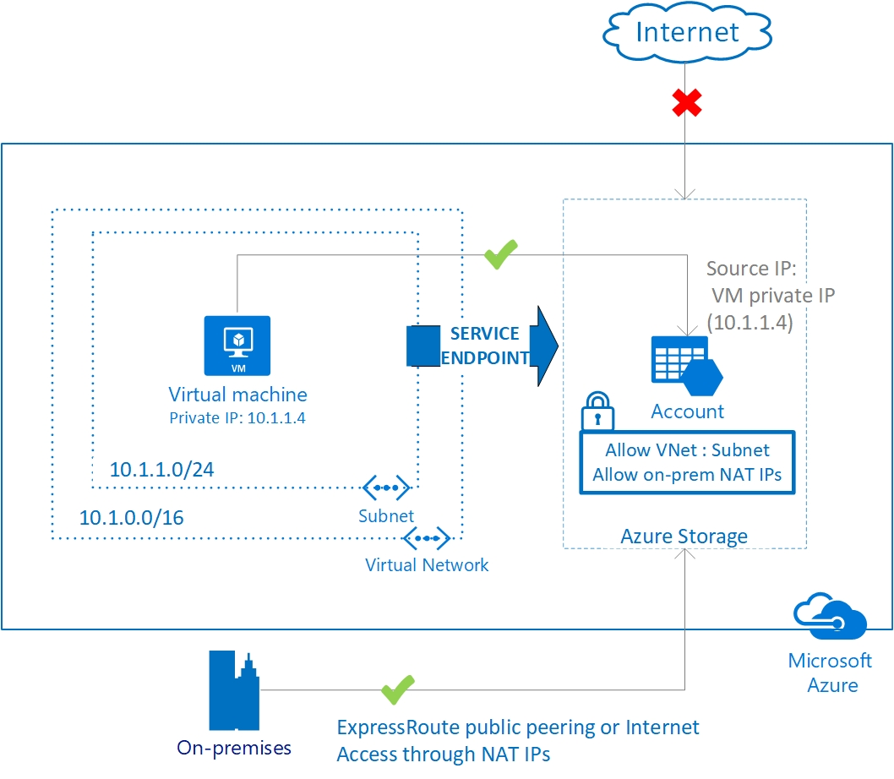

AZURE PRIVATE LINKS:
Azure Private Link enables you to access Azure PaaS Services (for example, Azure Storage and SQL Database) and Azure hosted customer-owned/partner services over a private endpoint in your virtual network.
Traffic between your virtual network and the service travels the Microsoft backbone network. Exposing your service to the public internet is no longer necessary. You can create your own private link service in your virtual network and deliver it to your customers. Setup and consumption using Azure Private Link is consistent across Azure PaaS, customer-owned, and shared partner services.
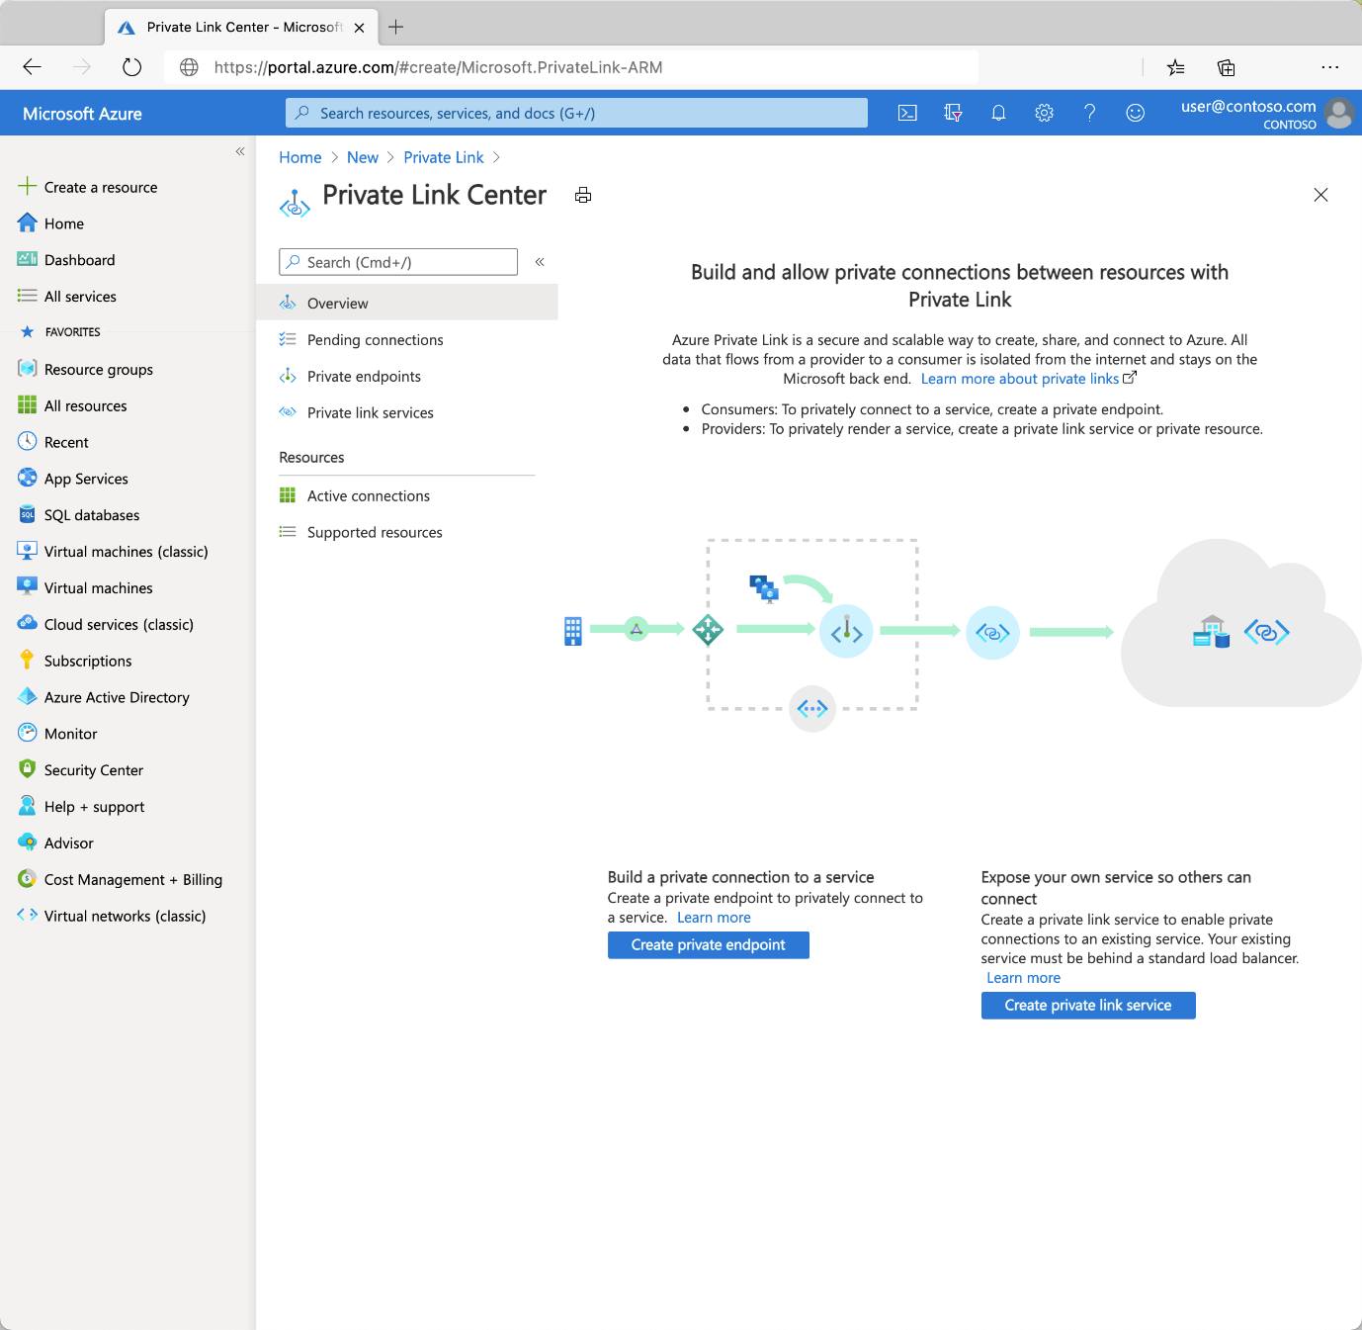

AZURE LOAD BALANCER:
Load balancing refers to evenly distributing load (incoming network traffic) across a group of backend resources or servers.
Azure Load Balancer operates at layer 4 of the Open Systems Interconnection (OSI) model. It's the single point of contact for clients. Load balancer distributes inbound flows that arrive at the load balancer's front end to backend pool instances. These flows are according to configured load-balancing rules and health probes. The backend pool instances can be Azure Virtual Machines or instances in a virtual machine scale set.
A public load balancer can provide outbound connections for virtual machines (VMs) inside your virtual network. These connections are accomplished by translating their private IP addresses to public IP addresses. Public Load Balancers are used to load balance internet traffic to your VMs.
An internal (or private) load balancer is used where private IPs are needed at the frontend only. Internal load balancers are used to load balance traffic inside a virtual network. A load balancer frontend can be accessed from an on-premises network in a hybrid scenario.

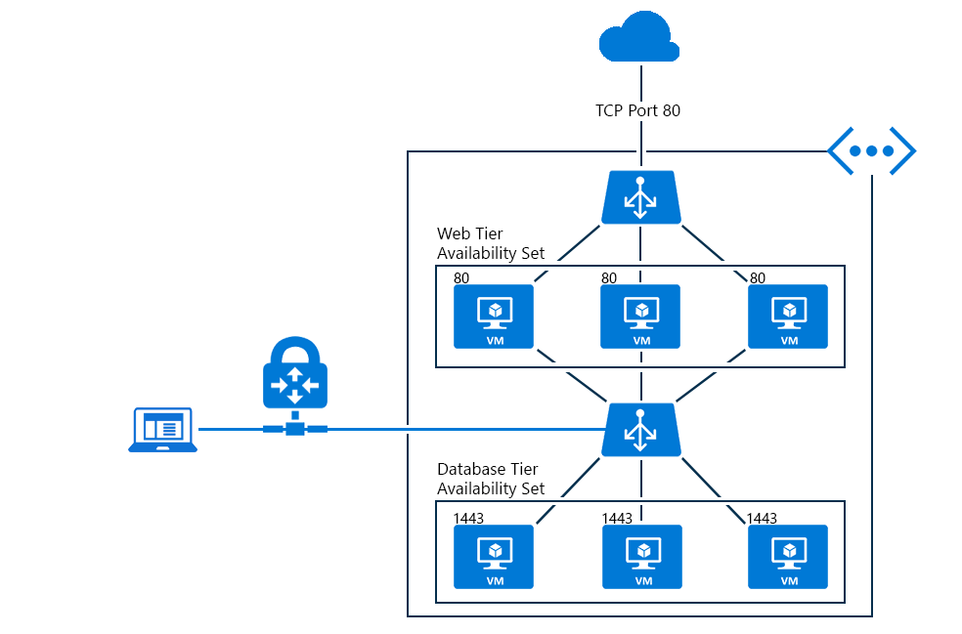

Feature | Basic SKU | Standard SKU
Backend pool | Up to 300 instances | Up to 1000 instances
Health probes | TCP, HTTP | TCP, HTTP, HTTPS
Availability zones | Not available | Zone-redundant and zonal frontends for inbound and outbound traffic
Multiple frontends | Inbound only | Inbound and outbound
Secure by default | Open by default. NSG optional. | Closed to inbound flows unless allowed by a NSG. Internal traffic from the virtual network to the internal load balancer is allowed.
SLA | Not available | 99.99%

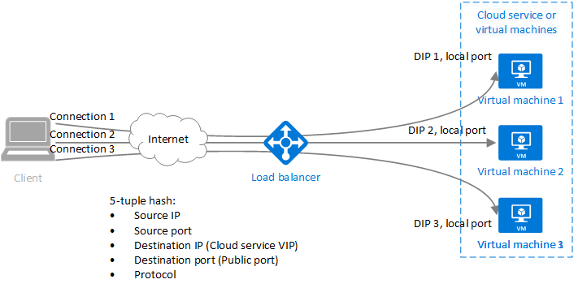

Health Probes:
When using load-balancing rules with Azure Load Balancer, you need to specify health probes to allow Load Balancer to detect the backend endpoint status. The configuration of the health probe and probe responses determine which backend pool instances will receive new flows. You can use health probes to detect the failure of an application on a backend endpoint. You can also generate a custom response to a health probe and use the health probe for flow control to manage load or planned downtime. When a health probe fails, Load Balancer will stop sending new flows to the respective unhealthy instance. Outbound connectivity is not impacted, only inbound connectivity is impacted.
Health probes support multiple protocols. The availability of a specific health probe protocol varies by Load Balancer SKU. Additionally, the behavior of the service varies by Load Balancer SKU as shown in this table:
LOAD BALANCER HEALTH PROBES
 | Standard SKU | Basic SKU
Probe types | TCP, HTTP, HTTPS | TCP, HTTP
Probe down behavior | All probes down, all TCP flows continue. | All probes down, all TCP flows expire.

AZURE APPICATION GATEWAY:
Azure Application Gateway is a web traffic load balancer that enables you to manage traffic to your web applications. Traditional load balancers operate at the transport layer (OSI layer 4 - TCP and UDP) and route traffic based on source IP address and port, to a destination IP address and port.
Application Gateway can make routing decisions based on additional attributes of an HTTP request, for example URI path or host headers. For example, you can route traffic based on the incoming URL. So if /images is in the incoming URL, you can route traffic to a specific set of servers (known as a pool) configured for images. If /video is in the URL, that traffic is routed to another pool that's optimized for videos.

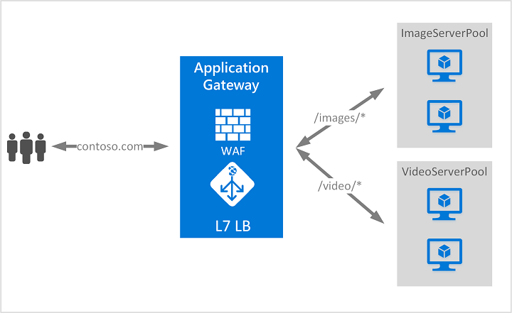

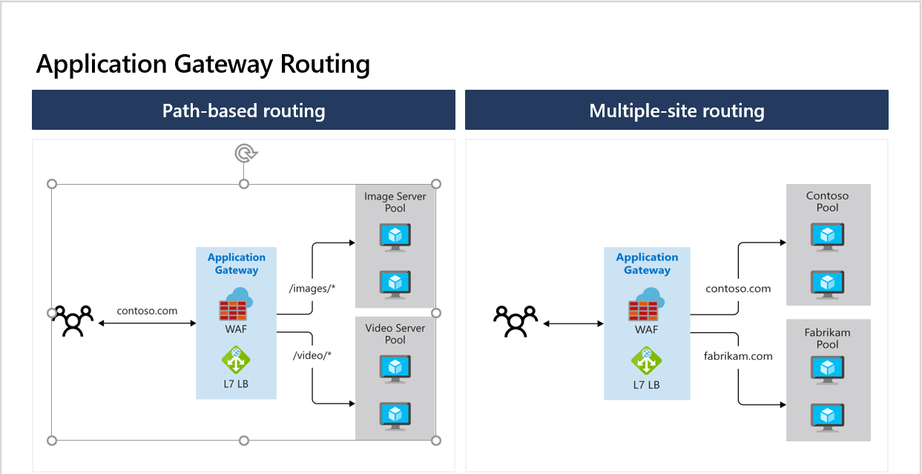

PATH BASED ROUTING:
STEPS FOR PRACTICAL :
Tutorial: URL path-based routing rules using portal - Azure Application Gateway | Microsoft Docs

Multi - Site Routing:
Hosting multiple sites on Azure Application Gateway | Microsoft Docs

